How to use SWISH - SWI-Prolog?

# Create your first Notebook

## Access the link: [swish.swi-prolog.org](https://swish.swi-prolog.org/)



## Create a Notebook

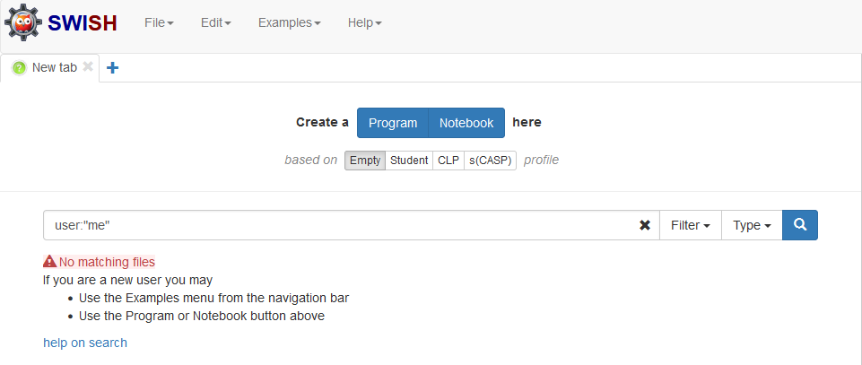

## This is how a Notebook should look

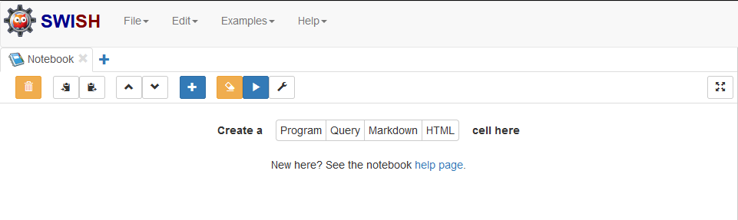

## Add a new cell



## Select Program

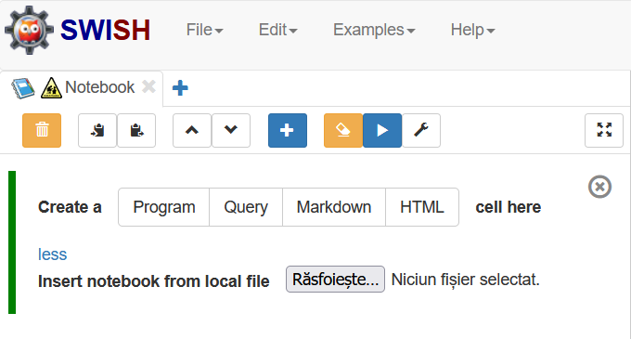

## Write your Prolog code

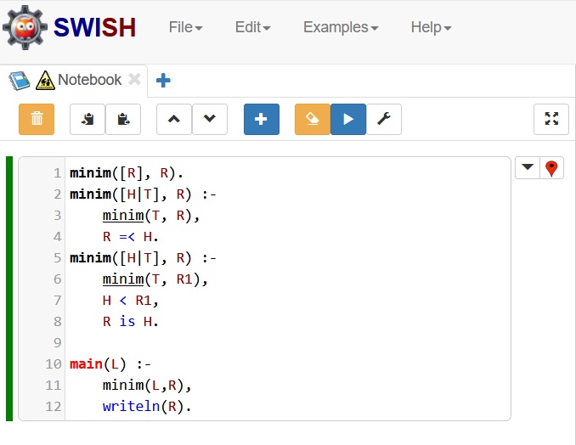

## In the right we can run the code

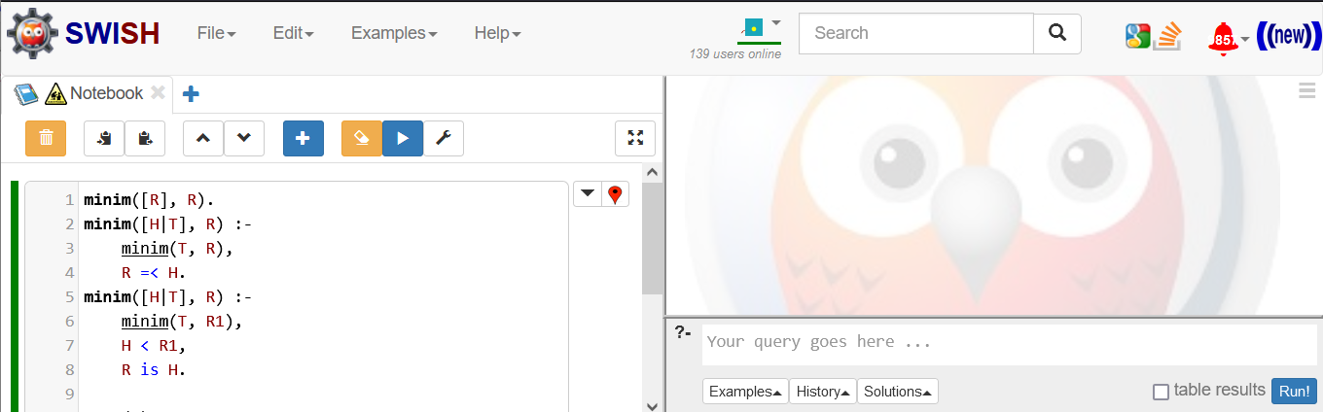

## Call your function and click Run

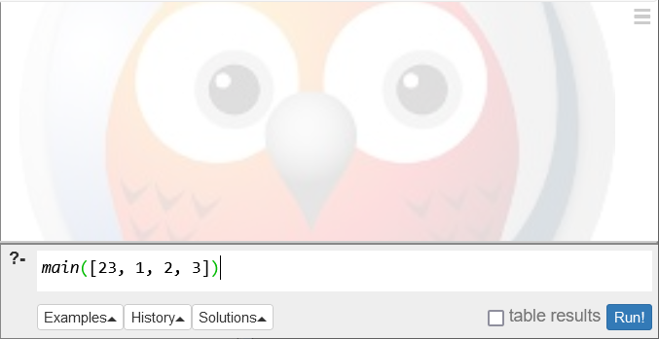

## If something is wrong, it will give you an error warning

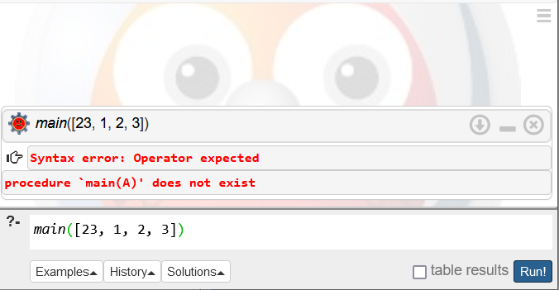

## Now you have the result

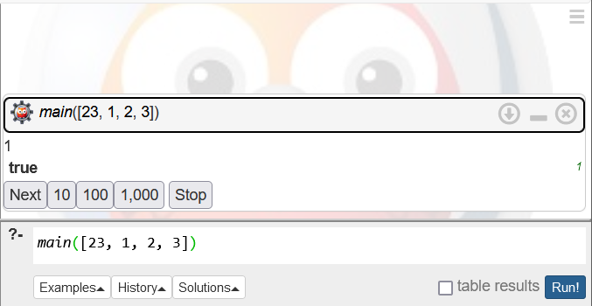

## Close the query when you are done



## Don’t let open too many queries at once

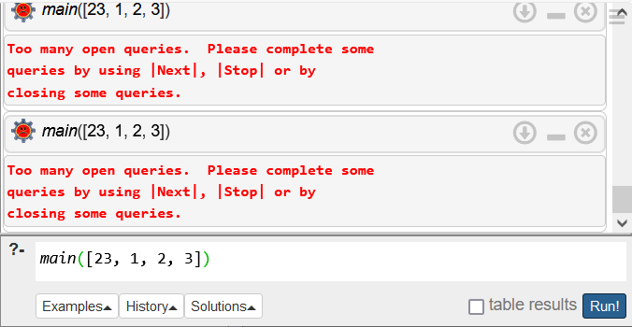

# Open an already created Notebook

## Access the link: [swish.swi-prolog.org](https://swish.swi-prolog.org/)



## Create a Notebook



## This is how a Notebook should look



## Add a new cell



## Select more

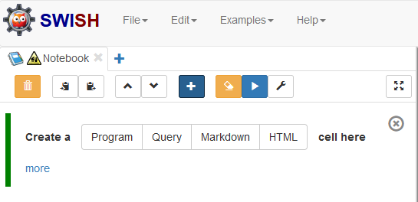

## Select Choose File

